**Feyza Nur SAKA**

**1521221051**

REGEX WEBSITE

Project name : Regex Website

The subject of the project : The subject of the project is website about regex.

Regex : Short for regular expression, a regex is a string of text that allows you to create patterns that help match, locate, and manage text. Perl is a great example of a programming language that utilizes regular expressions. However, its only one of the many places you can find regular expressions. Regular expressions can also be used from the command line and in text editors to find text within a file.

Where regex is used : Many programming languages, operating system commands, database queries and search applications uses Regular Expression. We are going to use it on HTML inputs for specific input type like Social ID, phone number, email, credit card number and validation date etc.

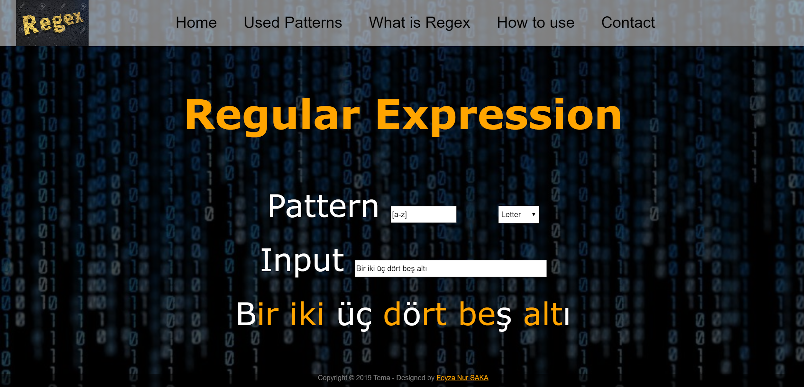

Used Patterns:

1. [a-z] : Find all lowercase letters in the alphabet.
2. [0-9]{4} : Find four of the numbers from 0 to 9, along with four.
3. d[iuü][km] : Find d letter, one of the letters i or ü or u, one of the letters k or m, that come one after another.
4. x[a-z] : Finds the lowercase letter after x and x.

References :

1. https://github.com/maeyler/Auto/blob/master/work/RegExp.html
2. https://www.regexbuddy.com/regex.html
3. <https://www.youtube.com/embed/909NfO1St0A>
4. <https://www.youtube.com/embed/r6I-Ahc0HB4>
5. <https://www.youtube.com/embed/paOPoZyjzdg>
6. <https://www.youtube.com/embed/7DG3kCDx53c>
7. https://www.youtube.com/embed/ykSuHWhh5hc